

**Faculty of Engineering**

**Preparatory Department**

**Smart Lock Using Arduino & Keypad**

A Graduation Project Report

Presented in Partial Fulfillment of the Requirements for GEN0001

Presented by

|  |  |  |
| --- | --- | --- |
| Name | Section | BN |
| Moamen Wael Sayed | 22 | 41 |
| Moayad Ahmed Abd El-Fattah | 43 |
| Kirollos Safwat Mofed | 15 |
| Kirollos Magdy Nasr | 17 |
| Loay Ashraf Mohamed | 23 |
| Kevin Ramy Emil | 21 |
| Kirollos Medhat Abdullah | 19 |
| Marcilino Adel Michael | 56 |
| Kirollos Sabry Nazim | 14 |
| Kirollos Bebawy Mahrous | 11 |

In partial fulfillment of the Requirements for

GEN0001 Practical and Engineering Applications (Physics part)

**Submitted to:** Eng. Yasser Hamed

**2022**

Table of Contents

Abstract 1

Motivation 1

Necessary Background 2

Literature Review 3

RFID Based Access Control System 3

Fingerprint-Based Locking System 3

Knock-Pattern Locking System 4

Wi-Fi Based Locking System 4

Retinal Scan 4

Pattern Lock 5

Voiceprint 5

Bluetooth Locking System 5

Market Research & Customers Feedback 7

Project Design 11

System Description 13

Project Hardware 14

Arduino Uno 14

4x4 Matrix Keypad 16

Servo Motor 17

16x2 LCD Display 17

Resistors 18

Project Software 18

Arduino IDE 18

TinkerCad 18

Project’s Code 19

Simulation 21

Project specifications 23

Arduino Uno 23

4x4 Matrix Keypad 23

LCD display 24

Servo motor 24

Resistors 24

Results 25

Stand By 25

Correct Password + Door opened 26

Wrong Password + Door closed 27

Conclusion 28

References 29

# ****Abstract****

There is no doubt that we need to defend our privacy from prying eyes in our daily life. So, we decided to present an effective solution to the current issue that has the best of the both worlds, security, and effectiveness.

Our project is a smart lock that is composed of an Arduino microcontroller which controls a mechanical lock according to the password entered by user using a keypad and displayed instructions on a screen.

# **Motivation**

In our daily lives, safety is a major concern. everybody wants to feel safe at his or her own home, workplace, and a safe environment. Smart door lock security system using Arduino is a project aimed at increasing and advancing the safety and security of lives and property of the people. The project deals primarily with the protection of doors and making it more secured within our house, office, or public related buildings. With the help of smart door lock, when indoors or while you are away from your home and workplace, the doors are protected primarily to grant access to only authorized persons using the password entered by a keypad. Keypad systems are one of the best ways to go [keyless](https://www.gvlock.com/blog/keyless-entry-what-you-need-to-know/) and safeguard a property. Traditional locks are no longer as secure as they once were; anyone can gain access by breaking these locks. We need to create a system that will assist 24 hours a day, seven days a week. Only authorized individuals have access to restricted areas thanks to a password-based door lock system. Arduino is in charge of the entire system. A keypad can be used to enter the password. The door opens if the password matches the password entered in Arduino. This password-based bolt structure will provide clients with a more secure and low-effort locking-opening mechanism. Mechanical door locks will be replaced by electronic door locks in the future, thanks to its **Convenience of a keyless system, Saving money and time from rekeying, Higher Security, Easy Installation and Moderate Cost (Range** 500EGP-650EGP). All these benefits would be very useful and helpful for a lot of people like shop owners and house owners, etc.

# **Necessary Background**

In this project, we implemented a Password-Based Security System Using Arduino & Keypad. As thefts are increasing day by day security is becoming a major concern nowadays. So, a digital code lock can secure our home or shop easily. It will open your door only when the right password is entered. Only authorized people are allowed access to the restricted sections due to a password-based door lock mechanism. The Arduino is responsible for the entire project's operation. The desired password can be entered using

a 4×4 keypad. A Keypad will allow us to input integer (from 0 to 9) or string (but within limits of ‘A’, ‘B’, ‘C’, ‘#’, ‘*’) or both and then compares the values with the string values that are set in the code. And if the password entered is the correct one the door will open by the servo motor which will rotates 90 degrees to open it. And if the password entered isn’t the correct one the door will remain closed as the servo motor won’t rotate and we will need to wait for 10 seconds to retry entering the password again ( as a way of more security ).

So, we can conclude that our main components are:

* **Hardware**

1. **Arduino Uno 4. 16x2 LCD Display**
2. **4x4 Matrix Keypad 5.** Resistors
3. **Servo Motor**

* **Software**

1. **Arduino IDE**
2. TinkerCad

# **Literature Review**

There are a few digital approaches for door security locks in the current system. This smart locking system takes the place of the classic lock and key locking method. Modern living is largely reliant on technological advancements, such as opening doors, managing the air conditioning, and controlling the curtains. People want to feel safe in their own homes, offices, and stores. The primary motivation for the development of smart locks is to meet the needs of people. Some of these systems will be discussed in this section.

### RFID Based Access Control System

Radio Frequency Identification (RFID) utilizes electromagnetic fields to automatically identify and track various objects. Most RFID systems include a microchip with an antenna (tag), a reader with an antenna and an access control server. An RFID system cross-references the data stored on the tag with its own database. If it matches, the access is then granted.

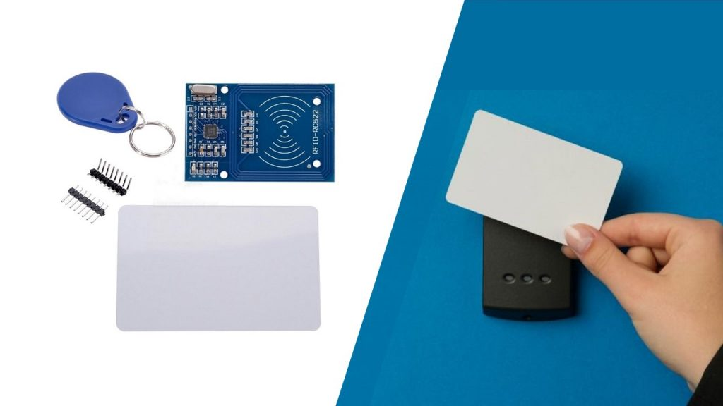

Figure-1: RFID Based Access Control System

### Fingerprint-Based Locking System

Although the name is self-explanatory, a fingerprint door lock may be defined as “a system which grants access to authorized personnel by virtue of recognizing their unique fingerprints.” You have probably looked at your hands countless times and noticed the **ridges and valley pattern**. Those patterns are very important as a method of identification. Human fingerprints are extremely detailed and nearly unique. With the technology, it can recognize and differentiate between fingerprints which used in securing access to a doorway.

### Knock-Pattern Locking System

This system employs a ‘Secret Knocking Pattern’ that is only known by the owner of the safe, other property, or item on which the device is mounted. For the lock to open, the knocking pattern must be used only at a certain location, which is only known by the owner. The secret pattern can only be changed after the secret knock has been unlocked. Because there is no key to be copied, this approach fully eliminates the worry of duplication.

### Wi-Fi Based Locking System

A keyless entry system that focuses on the use of an Arduino circuit board, a Wi-Fi module, and the PHP programming language to provide access to a closed door. The suggested solution, which uses an Arduino Uno board and a Wi-Fi shield to unlock the door without a key, is described. The internet connection allows the system to unlock the door from any place, unlike traditional systems, which have a limited range.

### Retinal Scan

A retinal scan is a biometric technique that uses unique patterns on a person's retina blood vessels.



Figure-2: Retinal Scan

### Pattern Lock

It’s one of the easiest and common secure method for our mobile phones. It requires a certain sequence of connected dots.



Figure-3: Pattern Lock

### Voiceprint

It’s a voiceprint recognition technique that verifies a speaker's identity by sound. After a user has read a short random password, the system quickly identifies the speaker's identity and unlocks.



Figure-4: Voiceprint

### Bluetooth Locking System

This type of smart lock is too useful for the places that used locks to be used for long time frequently. This type use Bluetooth field to determine the serial of assigned tool to make connection with the tool to make permission to the user to control the lock.

**Why Keypad Smart Lock?**

**Convenience of a Keyless System (auto opening)**

The biggest advantage is convenience. It eliminates the necessity of keys. There’s no need to carry them around, keep track of copies and spares, or change locks when a key is stolen or misplaced. Unlike the RFID.

**Offers Higher Security**

Keypad locks have a different hardware design than other types of locks. They don’t have cylinder mechanisms, so they essentially cannot be picked or bumped like conventional locks. This keeps the building more secure.

Instead of risking losing keys and having to rekey or change out the lock. With a keypad system, it’s easy to change the security pin code whenever necessary. And compared to Fingerprint (biometric) System it's harder to copy because it can be from 4 numbers up to 16 and can contain letters [A, B, C] or symbols such as [*,#]. That creates nearly an infinite number of possibilities.

**Enhanced Durability**

Traditional keys and locks wear down over time; it becomes more difficult to get it to turn and function properly. Keypads are much more durable than conventional locks. A high-quality lock and keypad device should last longer with standard hardware.

**Easy Installation**

Many property owners think that if they want to install a keypad lock, they’ll have to make major adjustments to door or frames. That’s not true. In most cases, keypad locks can be easily installed on standard doors, just like any standard lock. Compared to Bluetooth System it doesn't need a phone or a battery, so it solves the battery draining problem. If you run Bluetooth on a constantly on your smartphone, it will drain your battery fast. This runs the potential risk of getting you locked outside of your house if your phone runs out of battery.

# Market Research & Customers Feedback

Revenue from Smart Lock Industry from 2017 to 2021 Compared to Demand Outlook for 2022 to 2032

As per the latest analysis, the market value for the global smart lock market was estimated at nearly US$ 3.2 Bn in 2021, expanding at a stellar Y-o-Y rate of 15% during the historic period.

The soaring adoption of smart home architecture across the globe, which comprises features, like remote access, voice control, and seamless connectivity, is further driving the adoption of smart locks for residential premises. Owing to this, the market is poised to witness stupendous growth of 16% CAGR to expand to a valuation of approximately US$ 19 Bn during the forecast period.

How is Smart Lock Market Fostering in Asia?

Asia will offer the most remunerative growth opportunities with remarkable CAGR throughout the forecast period. Emerging countries with skilled workforces are revolutionizing disruptive smart lock technology. South Asia & Oceania are set to exhibit an astounding 22% CAGR through 2032.

Furthermore, rapid urbanization & progress in the net household disposable income, mounting awareness about automated solutions, hasty acceptance of internet-based services, progressions in communication technology & broadband services, and extensive adoption of the concept of the smart home in both the Indian and Chinese markets would propel the demand for smart locks in the province.

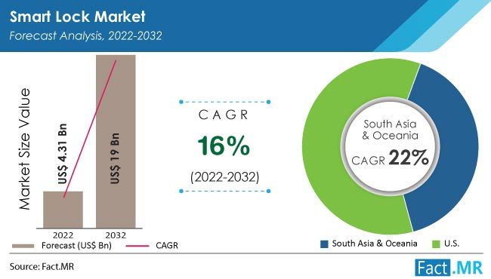

Figure-5: Smart Lock Market Size, Share, Trends & Growth, 2022-2032

Few days ago, we have made a survey to know how people feel about the smart lock using Arduino and keypad. Our first question was if people ever heard of the “Smart Lock” definition before. And yes, most of them knew about that definition before. Which will make our next questions easier to understand for them.

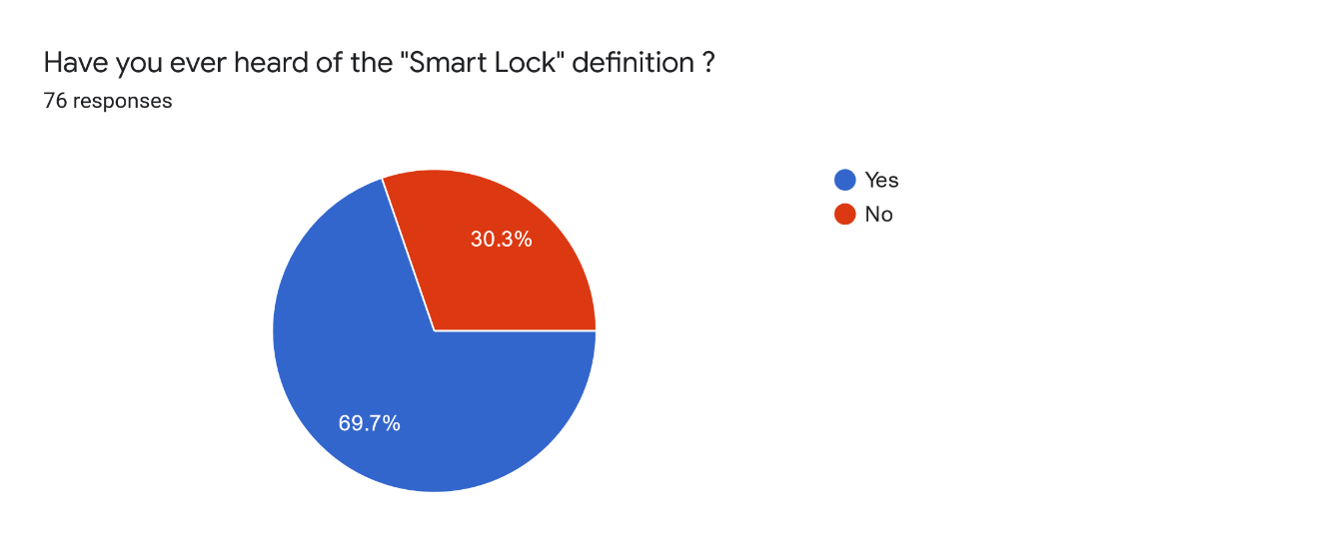Figure-6: Knowledge of “Smart Lock” definition

Then our second question was which locking method the customers prefer

(Smart lock or Traditional lock). Most of the answers were referring to the Smart lock as a preferred locking method.

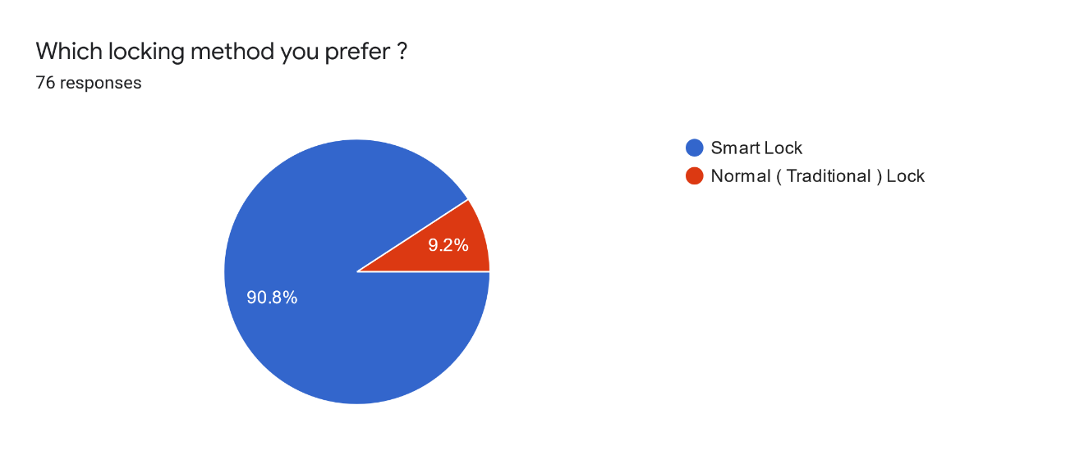Figure-7: Preferred locking method

The third question was about which smart lock system people prefer. And most answers were the keypad method using password. Which is the idea of our project.

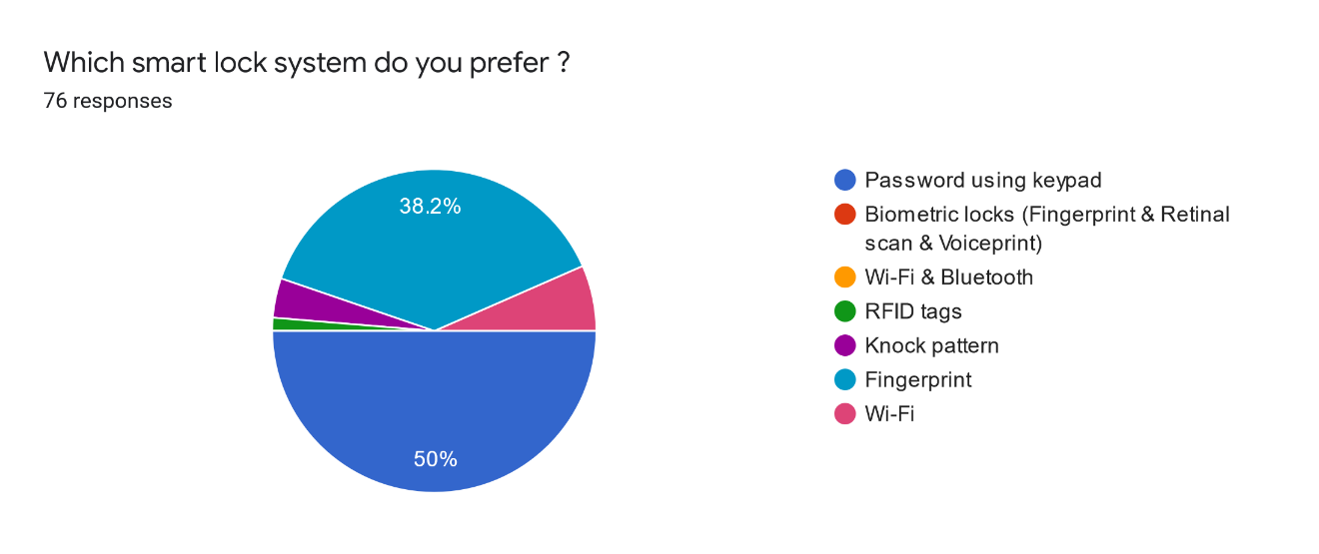Figure-8: Preferred smart lock system

The fourth question was about checking the price range we are offering in our product. And most answers were ok and satisfied with our price range. But the amount of people who said that the price range isn’t good can’t be ignored cause their percentage is 38.2%. But the main reason for the price we offered is the sudden rise of the dollar currency with respect to our currency “The Egyptian Pound”. So, after the dollar currency returns to its normal range. Our product’s price will go down to a new range (300EGP-400EGP).

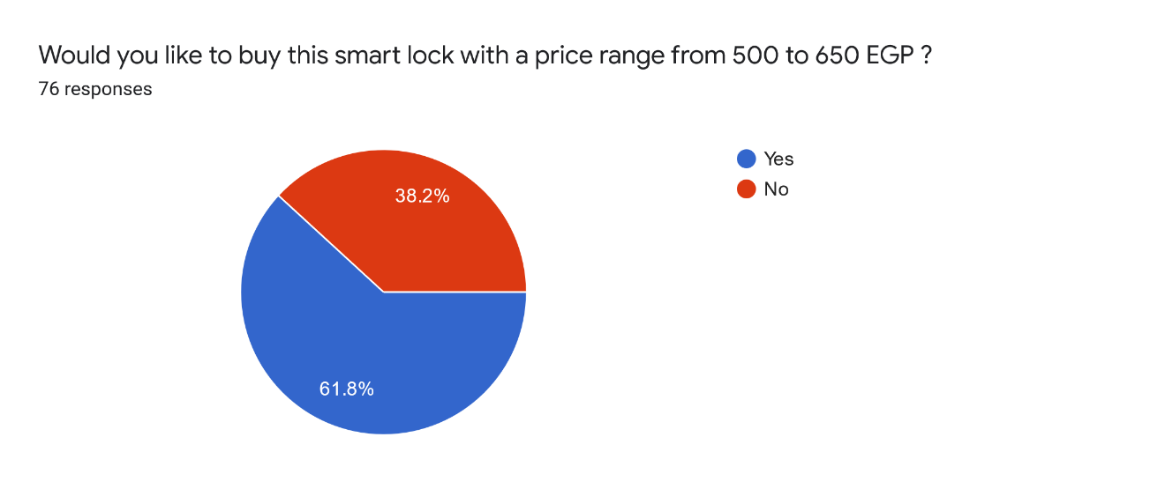

Figure-9: Satisfaction with the price

Our last question was if people have any suggestions to our product. And there are some of the answers we got:

1. U can add a camera to the lock so that u can see who's knocking outside.
2. I think if you could make this project without Arduino, it will make the project cheaper.
3. If wrong password 3 times call police.
4. It is good and all, but I think the price is little high.

# Project Design

After getting the password from the user, there are 2 scenarios that can happen:

1. Right Password ✓: the door gets opened.
2. Wrong Password X: the door gets closed in addition to waiting for 10 seconds till the next try.

This logic design can be schematized using the following flowchart:

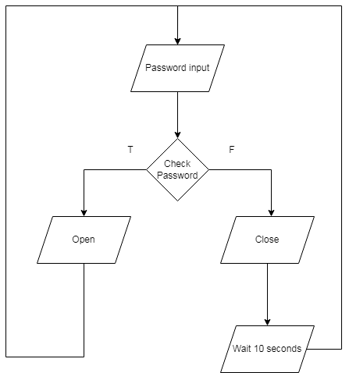

Figure-10: Flowchart

And by also using the following block diagram:

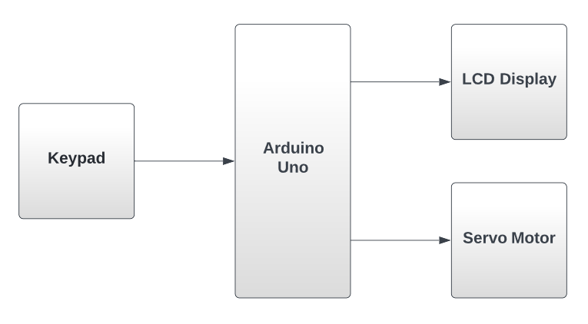Figure-11: Block diagram

We can use the schematic view of the project as a way of understanding the project’s circuit: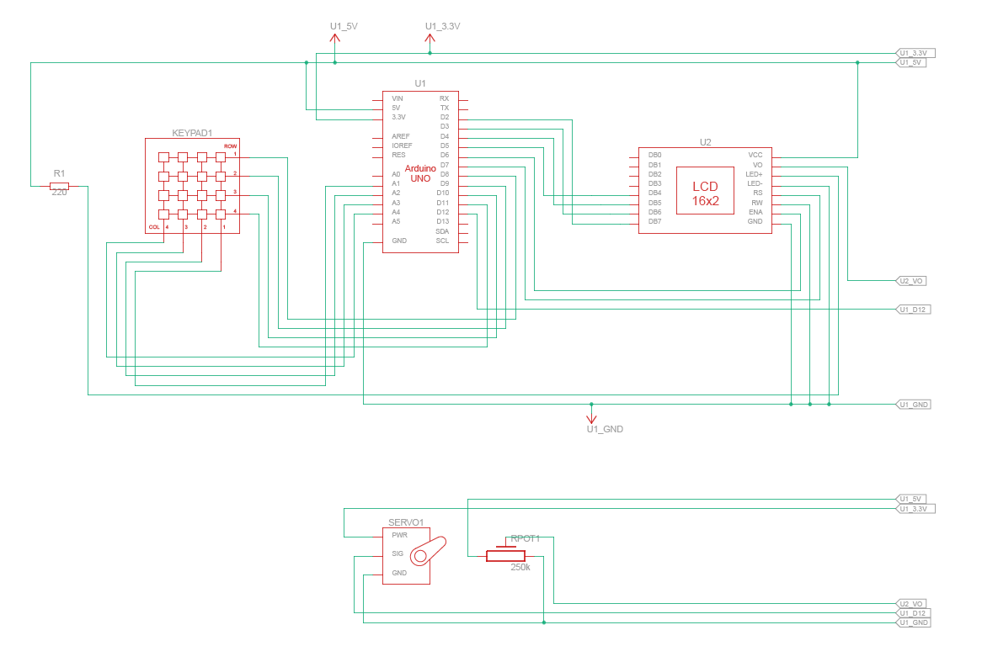

Figure-12: Schematic view

# System Description

We will try now to describe the total system in our words and its algorithm.

First, we will plug our project with an electricity with AC to DC power supply adapter 9V 1A. Then, we will need to enter the password using the keypad [ The password can be letters (from A to C) and/or symbols (* or #) and/or numbers (from 0 to 9) ] Then press button “D” ( like an Enter button when entering your password in any website ). So, there will be 2 cases:

**Case 1**: The password is correct:

if the password entered matches the password already fixed in the code, the keypad will send a signal to the LCD display and the “Correct password” message will appear on it and the Arduino will send a signal to Servo Motor (Which is connected to the door with a metal wire). The Motor will then rotate 90° allowing the door lock to be unlocked. **Then you will need to put a wrong password after entering to lock the door lock again Or lock it manually,** so that the motor will rotate 90° but in the opposite direction.

**Case 2**: The password is incorrect:

If the password inserted in the Keypad does not match the fixed password in the code, the Keypad will send a signal to the Display to show the “Wrong Password” message and the door lock won’t open. And we will need to wait 10 seconds to try again entering the password. Pressing the wrong values again in the Keypad will automatically instruct the user to start once again from the beginning. If the “Wrong Password” message is shown, the Servo Motor won’t rotate allowing the door lock to remain locked.

# Project Hardware

As mentioned before in the necessary background section that our main components are:

* **Hardware**

1. **Arduino Uno 4. 16x2 LCD Display**
2. **4x4 Matrix Keypad 5.** Resistors
3. **Servo Motor**

* **Software**

1. **Arduino IDE**
2. TinkerCad

* Now we talk about each component separately.

## ****Arduino Uno****

**Arduino is a microcontroller-based open-source electronic prototyping board which can be programmed with an easy-to-use software program called “Arduino IDE”.**



Figure-13: Arduino Uno

**USB connector:**

This is a printer USB port used to load a program from the Arduino IDE onto the Arduino board. The board can also be powered through this port.

**Power port:**

The Arduino board can be powered through an AC-to-DC adapter or a battery. The power source can be connected by plugging in a 2.1mm center-positive plug into the power jack of the board.

**Microcontroller:**

It’s used to store your program on it.

**Analog input pins:**

The Arduino UNO board has 6 analog input pins, labeled “Analog 0 to 5.” These pins can read the signal from an analog sensor like a temperature sensor and convert it into a digital value so that the system understands. These pins just measure voltage and not the current because they

have very high internal resistance. Hence, only a small amount of current flows through these pins. Although these pins are labeled analog and are analog input by default, these pins can also be used for digital input or output.

**Digital pins:**

You can find these pins labeled “Digital 0 to 13.” These pins can be used as either input or output pins. When used as output, these pins act as a power supply source for the components connected to them. When used as input pins, they read the signals from the component connected to them.

When digital pins are used as output pins, they supply 40 milliamps of current at 5 volts, which is more than enough to light an LED. Some of the digital pins are labeled with tilde (~) symbol next to the pin numbers (pin numbers 3, 5, 6, 9, 10, and 11). These pins act as normal digital pins but can also be used for Pulse-Width Modulation (PWM), which simulates analog output like fading an LED in and out.

**Reset switch:**

When this switch is clicked, it sends a logical pulse to the reset pin of the Microcontroller, and now runs the program again from the start. This can be very useful if your code doesn’t repeat, but you want to test it multiple times.

**Crystal oscillator:**

This is a quartz crystal oscillator which ticks 16 million times a second. On each tick, the microcontroller performs one operation, for example, addition, subtraction, etc.

**USB interface chip:**

Think of this as a signal translator. It converts signals in the USB level to a level that an Arduino UNO board understands.

**TX – RX LEDs:**

TX stands for transmit, and RX for receive. These are indicator LEDs which blink whenever the UNO board is transmitting or receiving data.

## ****4x4 Matrix Keypad****

**A keypad is a set of buttons arranged in a block or “pad” which bear digits, symbols, or alphabetical letters. Pads mostly containing numbers are called a numeric keypad.**

**The 4 x 4 matrix keypad usually is used as input in a project. It has 16 keys in total, which means the same input values. It is ultra-thin, easy to interface with any microcontroller and has an adhesive backing for easy mounting for a variety of applications.**

Matrix keypads use a combination of four rows and four columns to provide button states to the host device, typically a microcontroller. Underneath each key is a pushbutton, with one end connected to one row, and the other end connected to one column.

For the microcontroller to determine which button is pressed, it first needs to pull each of the four columns (pins 1-4) either low or high one at a time, and then poll the states of the four rows (pins 5-8). Depending on the states of the columns, the microcontroller can tell which button is pressed.

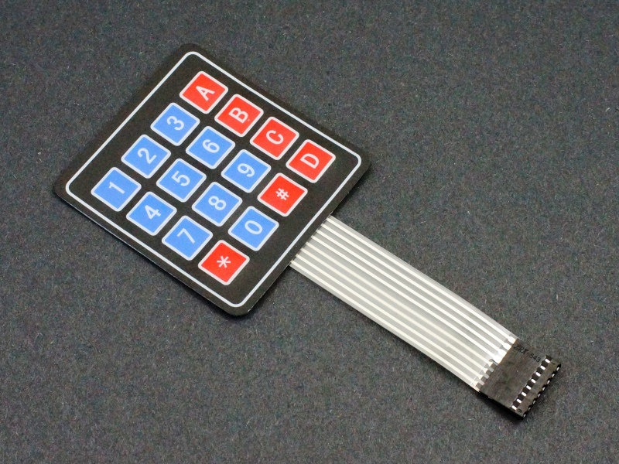

**Figure-14: 4x4 Matrix Keypad**

## ****Servo Motor****

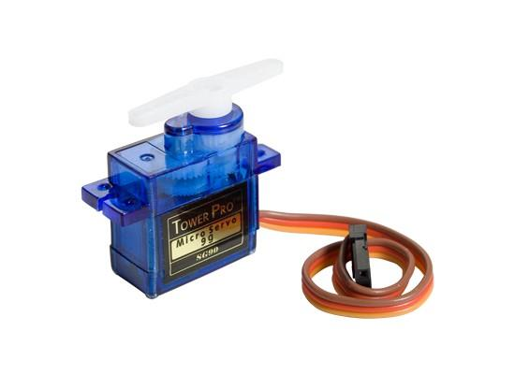Servo motors have three wires: power, ground, and signal. The power wire is typically red and should be connected to the 5V pin on the Arduino board. The ground wire is typically black or brown and should be connected to a ground pin on the board. The signal pin is typically yellow or orange and should be connected to PWM pin on the board. It can rotate from 0 degrees to 180 degrees. It’s used to open and close the door.

Figure-15: Servo Motor

## 16x2 LCD Display

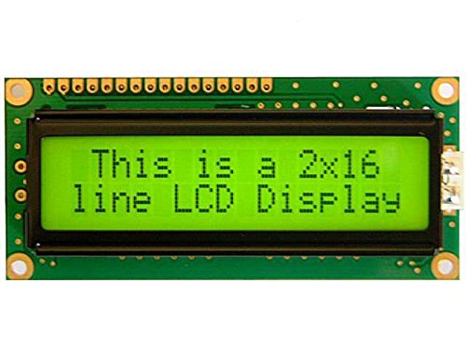An LCD (Liquid Crystal Display) screen is an electronic display module and has a wide range of applications. A 16x2 LCD display is very basic module and is very commonly used in various devices and circuits. A 16x2 LCD means it can display 16 characters per line and there are 2 such lines. In this LCD each character is displayed in 5x7 pixel matrix. The 16 x 2 intelligent alphanumeric dot matrix display can display 224 different characters and symbols. It has 16 Pins.

Figure-16: 16x2 LCD Display

## Resistors

As the name suggests, resistors resist the flow of electricity and the higher the value of the resistor, the more it resists, and the less electrical current will flow through it. We are going to use this to control how much electricity flows through the LCD display and therefore how brightly it shines.

Two types of resistors have been used, constant resistance and a potentiometer.



Figure-17: Constant resistance Figure-18: Potentiometer

# Project Software

## Arduino IDE

The Arduino IDE supports the language C and C++ using special rules of codes structuring. The Arduino IDE supplies a software library from the wiring project which provides many common input and output input basic functions, for starting the sketch and the main program loop that are compiled and linked with a program. It is mainly used for writing and compiling the code into the Arduino module there is a different range of Arduino modules we are going to use Arduino uno. The IDE environment mainly contains two basic parts: Editor and compiler where former is used for writing the required code and later is used for compiling and uploading the code into the given Arduino module.

## TinkerCad

TinkerCad is a website on the internet used for simulation in real time and design of circuits in 2D.

## Project’s Code

1. #include <LiquidCrystal.h>
2. #include <Keypad.h>
3. #include <Servo.h>
4. Servo servo_12;
5. #define led 13
6. // initialize the library with the numbers of the interface pins
7. LiquidCrystal lcd(7, 6, 5, 4, 3, 2);
8. const byte ROWS = 4; //four rows
9. const byte COLS = 4; //four columns
10. char keys[ROWS][COLS] = {
11. {'1','2','3','A'},
12. {'4','5','6','B'},
13. {'7','8','9','C'},
14. {'*','0','#','D'}
15. };
16. byte rowPins[ROWS] = {8, 9, 10, 11}; //connect to the row pinouts of the keypad
17. byte colPins[COLS] = {A1, A2, A3, A4}; //connect to the column pinouts of the keypad
18. Keypad keypad = Keypad( makeKeymap(keys), rowPins, colPins, ROWS, COLS );
19. char StorePass[]="*AC#090"; //The correct password
20. int i=0,count=0,number=sizeof(StorePass)-1;
21. char pass[sizeof(StorePass)-1];
23. void setup() {
24. // set up the LCD's number of columns and rows:
25. lcd.begin(16, 2);
26. // Print a message to the LCD.
27. lcd.print(" Enter Password ");
28. lcd.setCursor(0, 1);
29. pinMode(led,OUTPUT);
30. }
32. void loop()
33. {
34. char key = keypad.getKey();
36. if (key && key!='D')
37. {
38. lcd.print('*'); //print "*" for any clicken key from the keypad for more security
39. pass[i]=key;
40. i++;
41. }else if(key=='D') //"D" is like an Enter button when entering the password in any website
42. {
43. if(i==number)
44. {
45. for(int j=0;j<number;j++)
46. {
47. if(pass[j]==StorePass[j])count++;
48. }
49. if(count==number)
50. {
51. lcd.clear();
52. digitalWrite(led,HIGH);
53. lcd.setCursor(0,0);
54. lcd.print("Correct Password");
55. servo_12.attach(12);
56. servo_12.write(90);
57. delay(2000);
58. i=0;
59. count=0;
60. lcd.setCursor(0,0);
61. lcd.print(" Enter Password ");
62. lcd.setCursor(0,1);
63. }else
64. {
65. printt();
66. }
67. }else
68. {
69. printt();
70. }
71. }
72. }
74. void printt()
75. {
76. lcd.clear();
77. digitalWrite(led,LOW);
78. lcd.setCursor(0,0);
79. lcd.print(" Wrong Password");
80. servo_12.write(0);
81. delay(2000);
82. lcd.setCursor(0,1);
83. lcd.print("Try Again In");
84. lcd.setCursor(13,1);
85. lcd.print("10!");
86. delay(1000);
87. for(int k=9;k>=0;k--)
88. {
89. lcd.setCursor(13,1);
90. lcd.print(0);
91. lcd.print(k);
92. delay(1000);
93. }
94. lcd.clear();
95. i=0;
96. count=0;
97. lcd.setCursor(0,0);
98. lcd.print(" Enter Password ");
99. lcd.setCursor(0,1);
100. }

# Simulation

The simulation has been done using TinkerCad website.

And here is the link if you want to open it live from TinkerCad website:

<https://www.tinkercad.com/things/h81lvyWT4Oj-smartlock-using-arduino-keypad/editel?sharecode=qKez-byYLSDfLpZByFzPg2jpCfC6DVSkNxIAlqeTVP8>

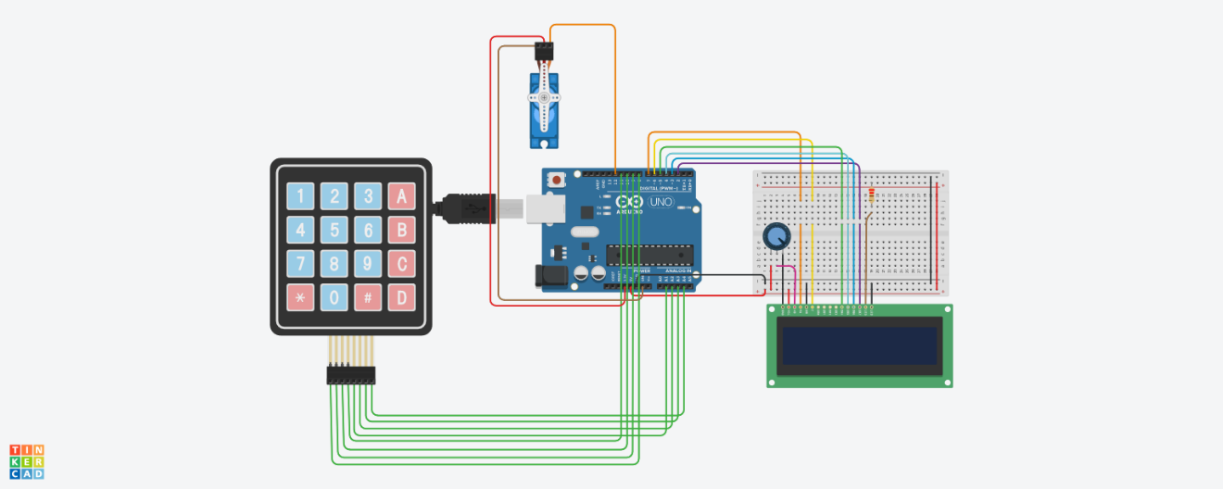

Figure-19: TinkerCad simulation

* Wrong password + Door closed

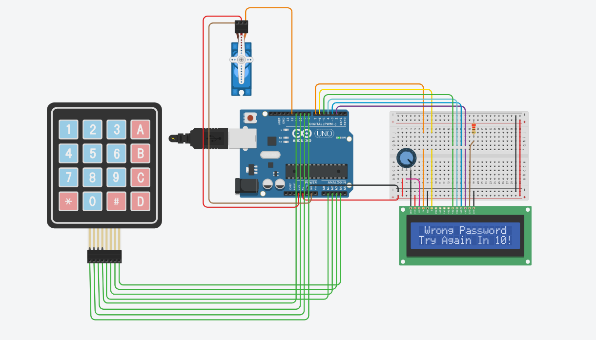

Figure-20: Wrong password simulation

* Correct password + Door opened

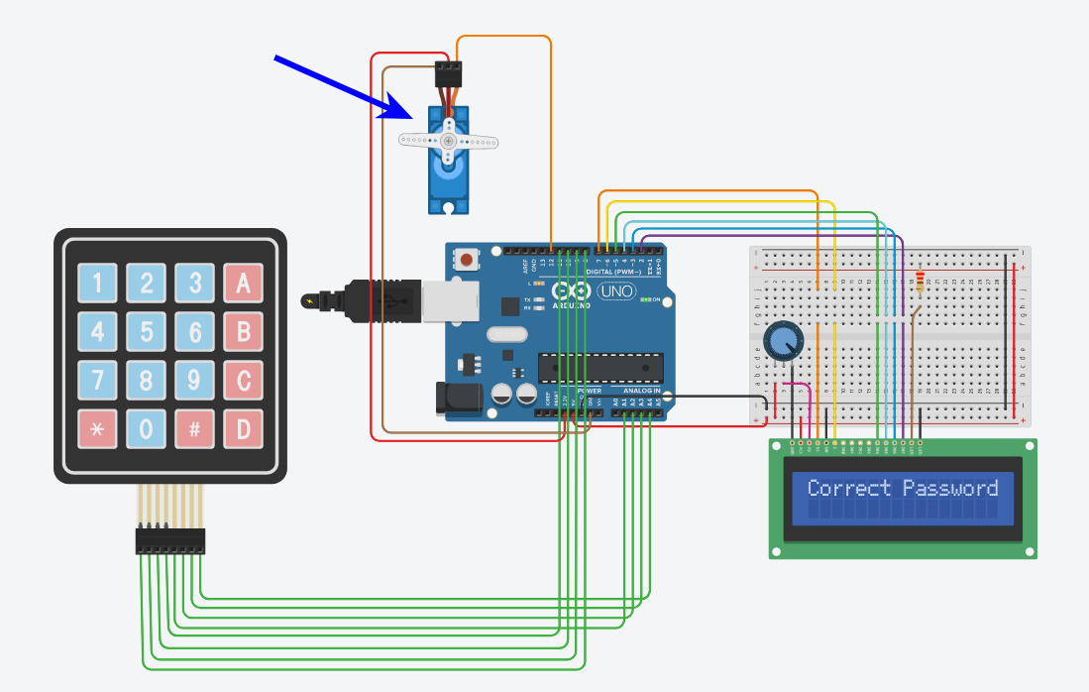

Figure-21:Correct password simulation

# Project specifications

## Arduino Uno

|  |  |
| --- | --- |
| Operating voltage | 5V |
| Input voltage (recommended) | 7-12V |
| Input voltage (limit) | 6-20V |
| Digital I/O pins | 14 (of which 6 provide PWM output) |
| PWM digital I/O pins | 6 |
| Clock speed | 16 MHz |
| Length | 68.6 mm |
| Width | 53.4 mm |
| Weight | 25 g |

## 4x4 Matrix Keypad

|  |  |
| --- | --- |
| Maximum Voltage rating | 24V DC |
| Maximum Current rating | 30 mA |
| Operating temp range | 32 to 122 °F (0 to 50 °C) |
| Numbers of Pin | 8 |
| Keypad Dimensions | 6.9 cm X 7.9 cm |
| Cable dimensions | 2.0 cm X 8.8 cm |

## LCD display

|  |  |
| --- | --- |
| Operating voltage | 5 V |
| Screen resolution | 2-lines x 16 characters |
| Character resolution | 5 x 8 pixels |
| Module dimensions | 80 x 36 x 12 mm |
| Viewing area dimensions | 64.5 x 16.4 mm |

## Servo motor

|  |  |
| --- | --- |
| Power | 4.8 ~ 6V |
| Average Speed | 0.09s/60° (4.8V), 0.08s/60° (6V) |
| Weight | 10.5g |
| Torque | 2.0kg/cm (4.8V), 2.2kg/cm (6V) |
| Size mm: (L x W x H) | 22.8mm × 12.2mm × 28.5mm |
| Rotate angle | 180° |

## Resistors

|  |  |
| --- | --- |
| Resistance | 220 Ω |
| Potentiometer | 250 kΩ |

# Results

We managed to achieve our goal which is a keyless and secure locking system by password using the Arduino Uno. And we also managed to provide the whole system in 640 EGP. Keypad locking system nowadays doesn't target low-income customers, so stores sell their products at a high cost to huge corporations and businessmen providing it in 3,056 EGP ([on Jumia](https://www.jumia.com.eg/generic-digital-door-lock-keyless-keypad-door-coded-lock-door-lock-smart-digital-room-lock-combination-door-lock-21094729.html)) and that led us to simplify the system and lower its price.

|  |  |
| --- | --- |
| **Part** | **Price** |
| Arduino Uno & its cable | 365 EGP |
| Jumper Wires | 40 EGP |
| Breadboard | 30 EGP |
| Wall adapter AC to DC 9V 1A | 50 EGP |
| Servo motor | 85 EGP |
| LCD 16x2 | 45 EGP |
| Resistors | 3 EGP |
| Keypad | 22 EGP |

{ Prices from [RAM Electronics store](https://ram-e-shop.com/) and [El Nekhely Electronics](https://elnekhely.com) store }

And here are some pictures from our project after it has completely finished.

## Stand By

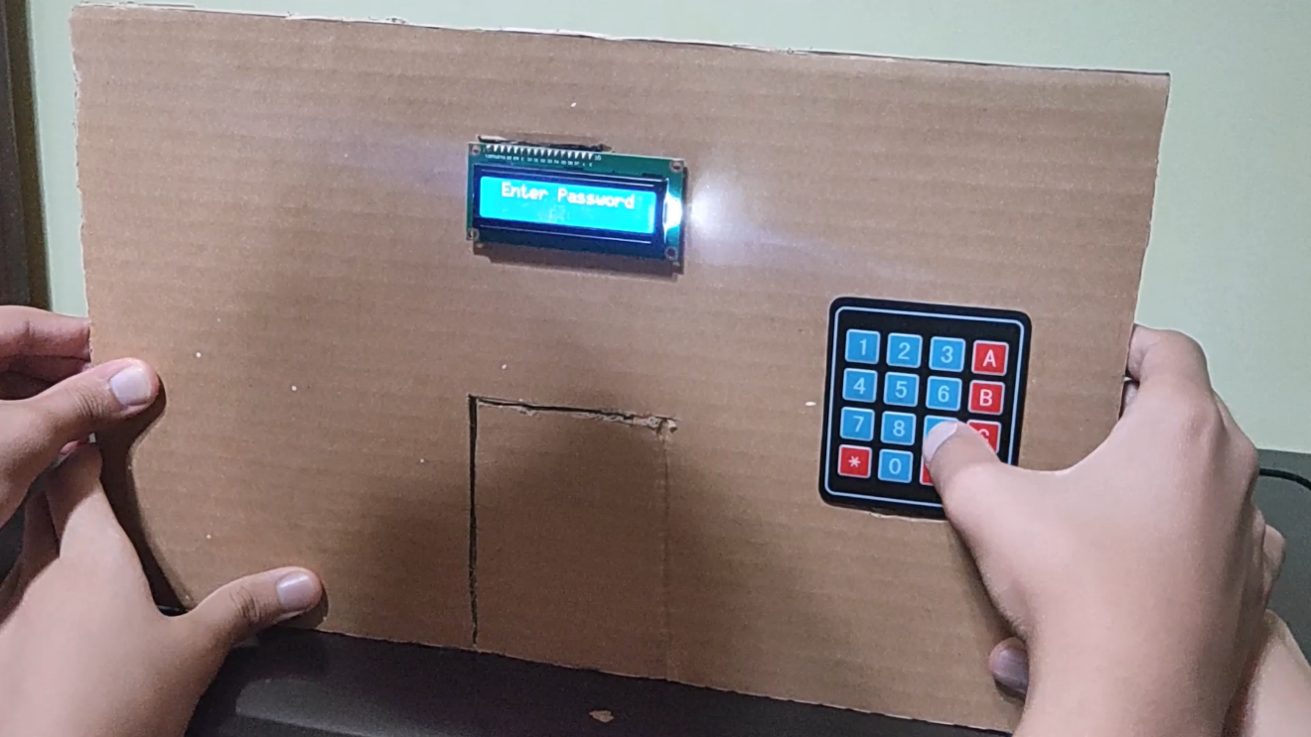

Figure-22: Stand By

## Correct Password + Door opened

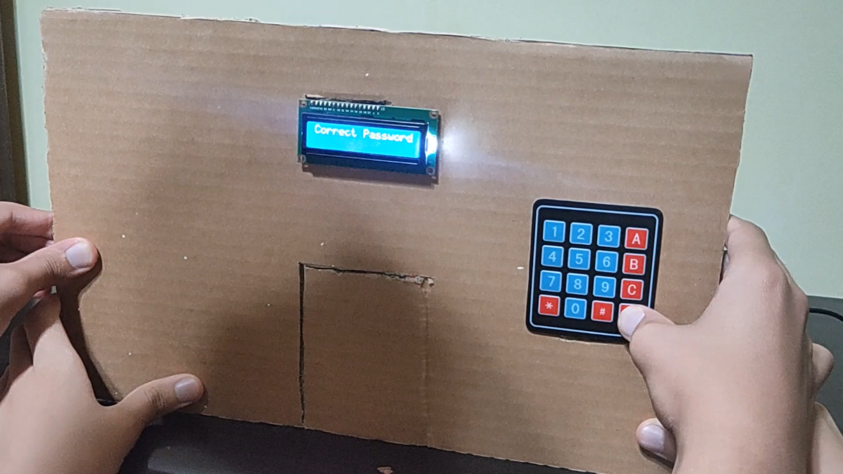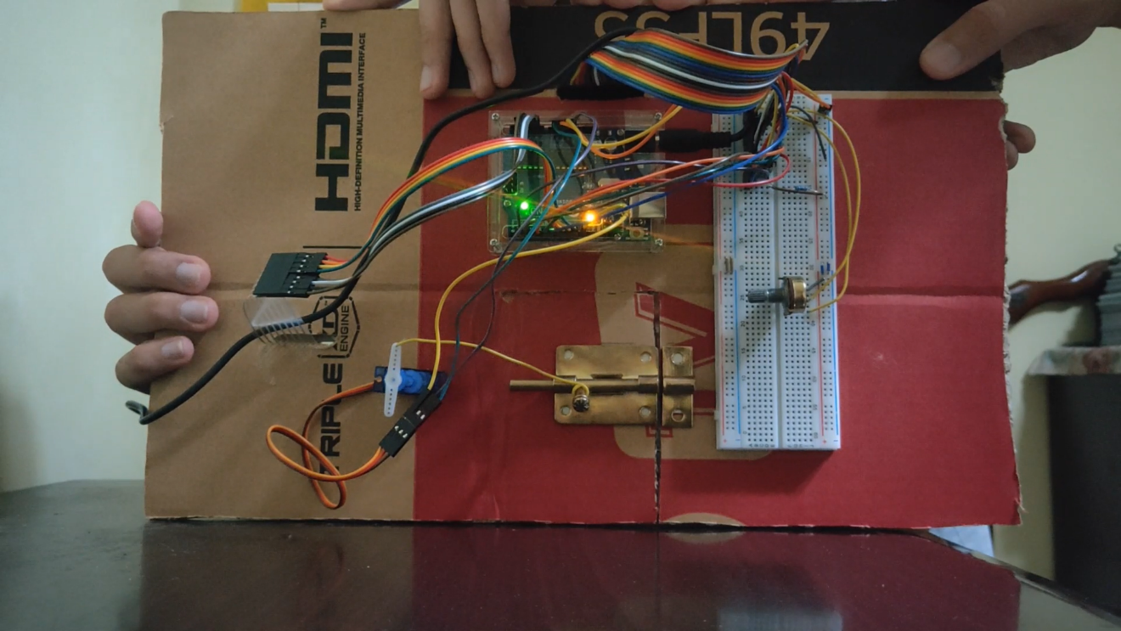

Figure-23: Correct Password + Door opened

## Wrong Password + Door closed

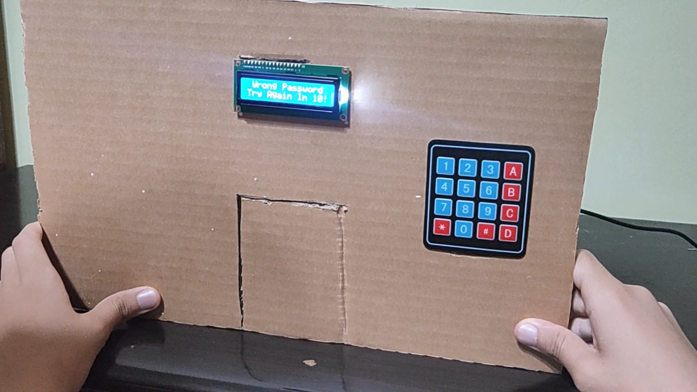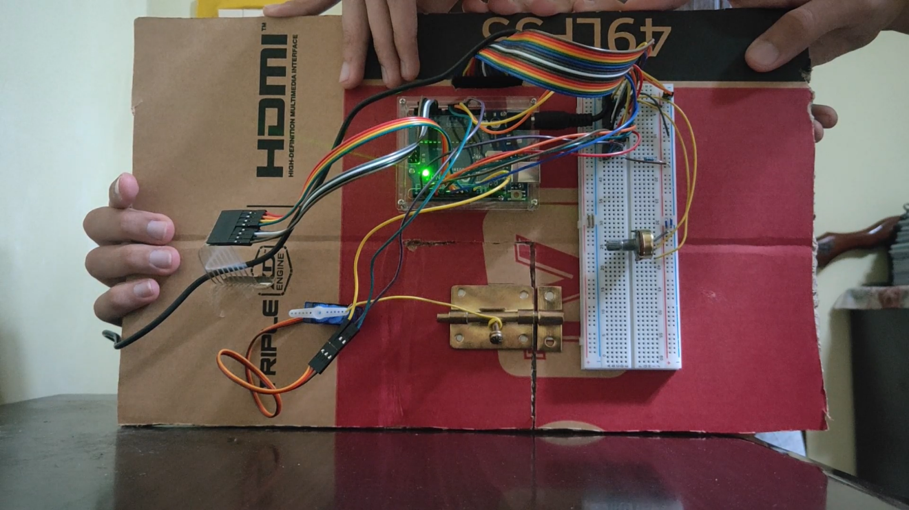

Figure-24: Wrong Password + Door closed

# ****Conclusion****

Using simple materials and tools, project objectives were successfully achieved. The present lock represents a well-made solution for anyone who seeks security at an affordable price.

Furthermore, mass production can be accomplished using modern manufacturing process to produce many locks in very short time in addition to increasing accuracy and decreasing the cost per product even more.



# ****References****

* <https://www.gvlock.com/blog/keypad-locks-101/>
* **https://circuitdigest.com/microcontroller-projects/digital-keypad-security-door-lock-using-arduino**
* <https://blog.nortechcontrol.com/rfid-access-control/>
* <https://www.bayometric.com/how-do-fingerprint-door-locks-work/>
* <https://www.researchgate.net/publication/339602257_SmaCk_Smart_Knock_Security_Drawer_Based_on_Knock-Pattern_using_Piezo-electric_Effect/>
* **Marwa F. Areed,** “**A keyless Entry System based on Arduino board with Wi-Fi technology**”: <https://doi.org/10.1016/j.measurement.2019.02.028/>
* <https://en.wikipedia.org/wiki/Retinal_scan/>
* [https://www.researchgate.net/publication/339362955_Smart_Lock_Systems_An_Overview](https://www.researchgate.net/publication/339362955_Smart_Lock_Systems_An_Overview?fbclid=IwAR2lRwhm7qM0_M7MRJTmXLEdxb_3iMCg2PhqBoG5lUL0gnvNuyCfLW4NhtA)
* <https://www.factmr.com/report/4669/smart-lock-market/>
* <https://www.hackerearth.com/blog/developers/a-tour-of-the-arduino-uno-board/>
* <https://osoyoo.com/2017/09/13/arduino-lesson-4x4-matrix-keypad/>
* <https://www.electronicsforu.com/technology-trends/learn-electronics/16x2-lcd-pinout-diagram>
* <https://learn.adafruit.com/adafruit-arduino-lesson-2-leds/resistors/>
* <https://www.coursehero.com/file/127936960/Arduinodocx/>
* <http://store-usa.arduino.cc/products/arduino-uno-rev3/>
* <https://www.electroduino.com/4x4-keypad-module/>
* <https://www.makerguides.com/character-lcd-arduino-tutorial/>
* <https://www.waveshare.com/sg90-servo.htm>